use db;

create table Student_Details(Roll_No varchar(5) primary key,Fullname varchar(30),DOB date,

DOJ date);

alter table Student_Details add Mobile_NO int8;

alter table Student_Details add unique(Mobile_NO);

insert into Student_Details values('561','Kota Keerthi Renuka','2002-06-11','2019-08-05','CSE',9542673240);

insert into Student_Details values('5G0','Koppula Supriya','2000-08-15','2019-08-05',9949294618);

insert into Student_Details values('462','Balki Rachana','2001-09-25','2019-08-05',7652819012);

insert into Student_Details values('221','Banoth Soniya','2001-08-10','2019-08-05',9542617240);

insert into Student_Details values('12A0','Dharmana Mounika','2002-07-16','2019-08-05',8882673240);

insert into Student_Details values('212','Nadikude Vrinda','2001-08-09','2019-08-05',7654273240);

insert into Student_Details values('1213','Challa Priyanka','2002-04-13','2019-08-05',7842673141);

select * from student_Details;

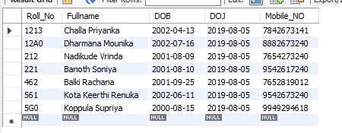

create table academic_details(Roll_No varchar(5) NOT NULL,Dept varchar(20),Attendence float,Email_Id varchar(25),

foreign key(Roll_No)references Student_Details(Roll_No));

insert into academic_details values('561','CSE',94.9,'keerthi55kota@gmail.com');

insert into academic_details values('5G0','CSE',98,'supriyakoppula@gmail.com');

insert into academic_details values('462','ECE',91.4,'Balkirachana@gmail.com');

insert into academic_details values('221','EEE',92.9,'SoniyaBanoth@gmail.com');

insert into academic_details values('12A0','IT',97,'mounika1010@gmail.com');

insert into academic_details values('1213','IT',95.4,'challapriyanka@gmail.com');

select*from academic_details;

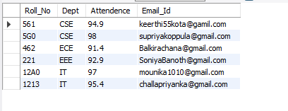

create table marks(Roll_No varchar(5),BEFA int,OS int,DM int,JP int,DBMS int,

foreign key(Roll_No) references student_Details(Roll_No));

insert into marks values('561',25,21,22,21,23);

insert into marks values('5G0',25,23,21,19,24);

insert into marks values('12A0',22,21,23,19,25);

insert into marks values('221',21,18,24,20,22);

insert into marks values('1213',24,22,25,19,24);

insert into marks values('462',21,22,25,23,24);

select * from marks;

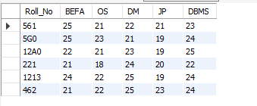

#count

select count(OS)from marks where OS>21;



#average

select Avg(DBMS) from marks where DBMS>19;



#min

select Roll_No,min(Attendence) from academic_details;

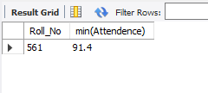

#max

select max(JP) as HighestMarks_in_JP from marks;

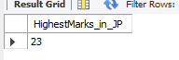

#sum

select sum(DM) from marks;



#groupby

select Roll_No from academic_details where Attendence > 94 group by Attendence;

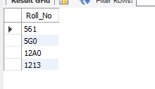

select Roll_No,FullName,Mobile_No from Student_details Group by Mobile_No;

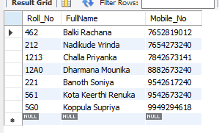

#order by

SELECT COUNT(Roll_No), Dept

FROM academic_details

GROUP BY Dept

ORDER BY COUNT(Roll_No) DESC;

